Edgar Arroyo

March 28, 2024

Module 1.2: GitHub Repository Setup

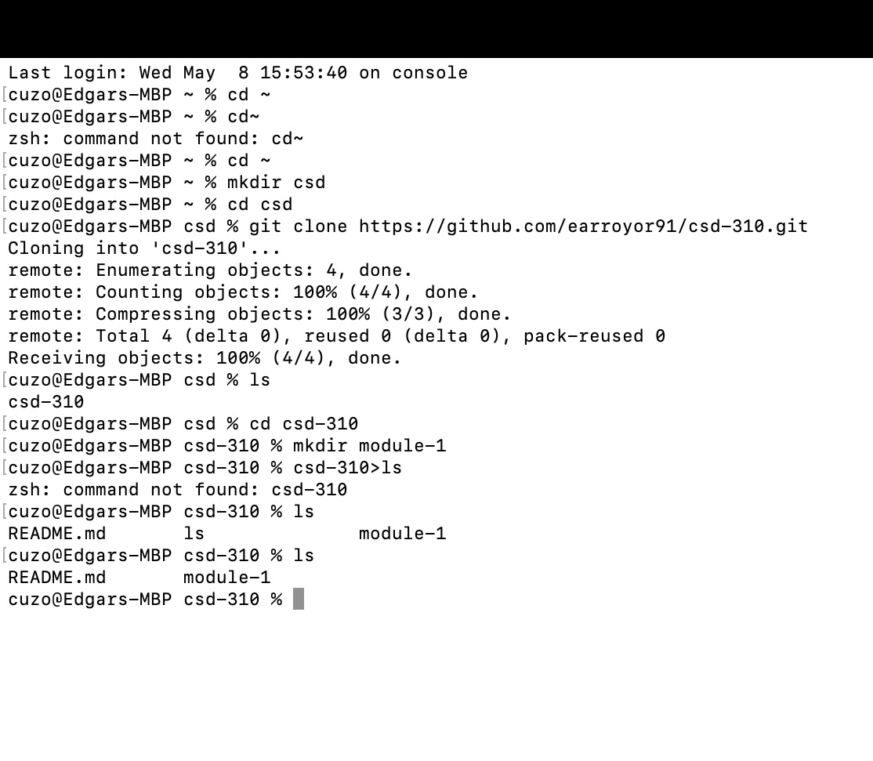

L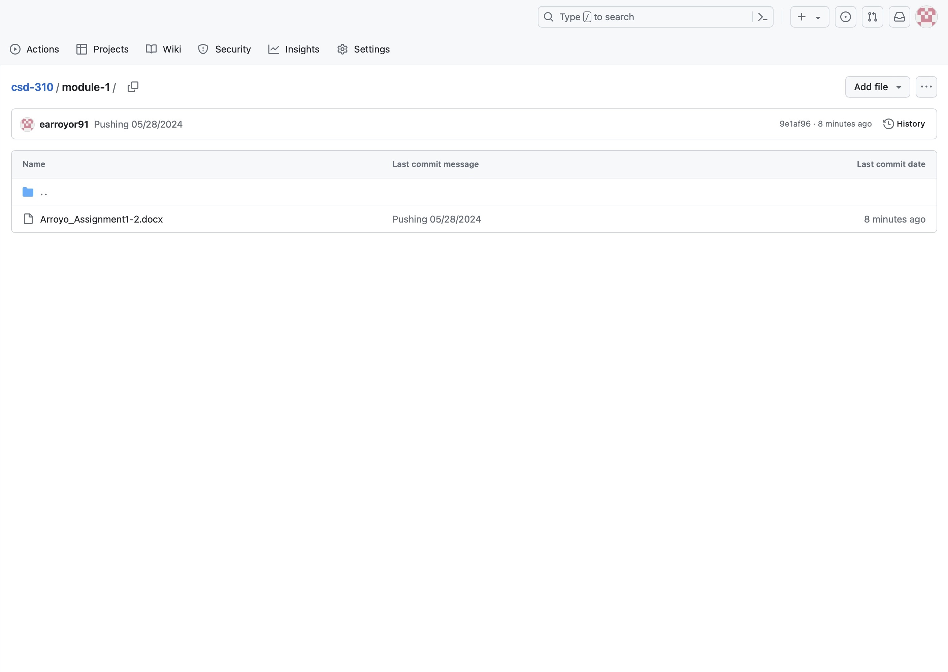ink:

<https://github.com/earroyor91/csd-310.git>